# CS 255 System Design Document Template

## UML Diagrams

### UML Use Case Diagram

### 

### UML Activity Diagrams

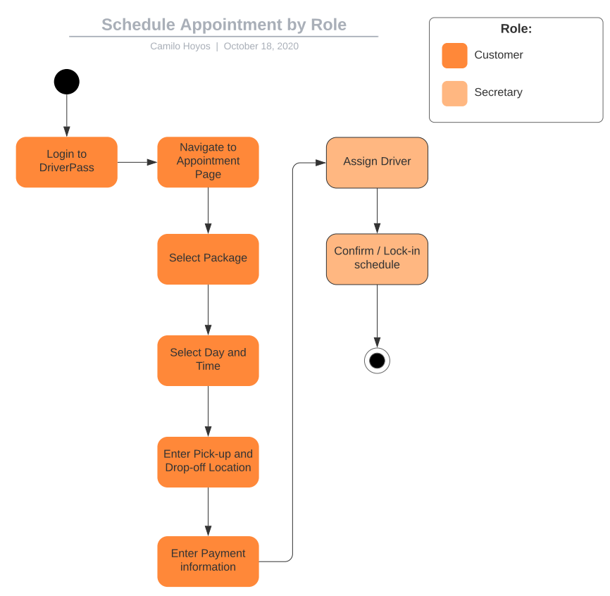

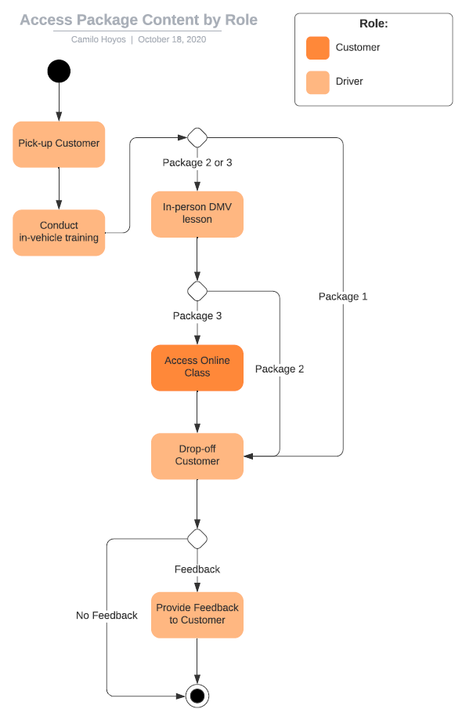

### UML Sequence Diagram

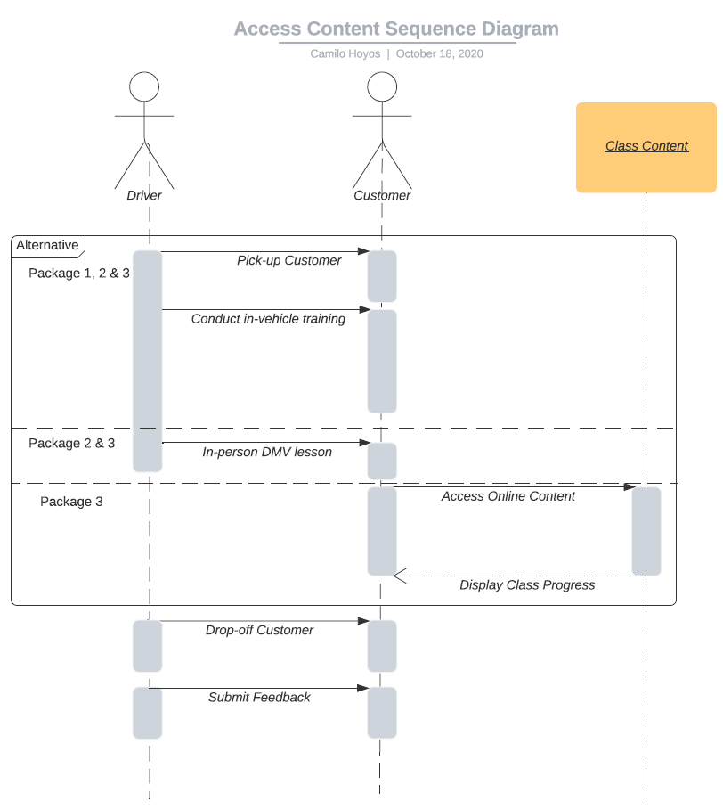

### UML Class Diagram

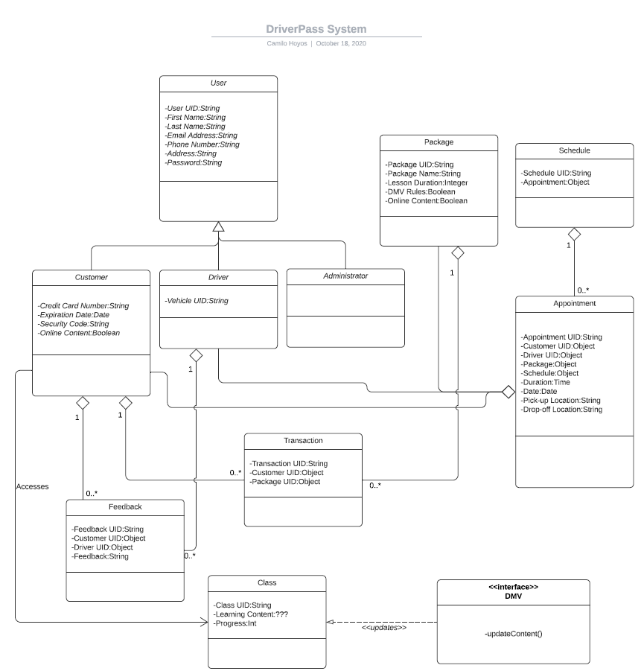

## Technical Requirements

1. Hardware
   1. None at this time
2. Software
   1. Interface with 3rd party (DMV)
   2. Accessible from mobile device
   3. Actions taken in system must be auditable/recorded
3. Infrastructure
   1. Cloud hosted
      1. No vendors specified (AWS, Azure, Google, etc…)
   2. Web application
      1. No browsers specified(Chrome, Edge, Safari, Mozilla, etc…)